COSHH Risk Assessment |  |  |  |  |  |  | Ref: | MSDS-
Manufacturer |  |  | Product
Work Activity/process
(incl. how long, how often, quantity used)
Who uses it
Location of use
Identify persons at risk: | Employees | ☐ | Contractors |  | ☐ | Public/Visitors |  |  | ☐
For Substances with Workplace Exposure Limit (WEL):
(WELs can be found in EH40 which is available from the HSE Website or via this link)
Short Term Exposure  Limit (STEL):  (15-min reference period): | ppm:  mg.m⁻³: |  | Long Term Exposure Limit (TWA):  (8-hr reference period): |  |  | ppm:  mg.m⁻³:

Classification
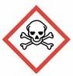  Toxic/  Danger | ☐ | 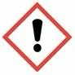  Warning/  Caution | ☐ | 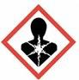  Long Term  Health Hazard | ☐ | 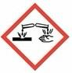  Corrosive | ☐
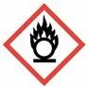  Oxidiser | ☐ | 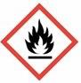  Flammable | ☐ | 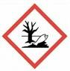  Danger to  Environment | ☐ | 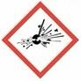  Explosive | ☐
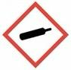  Compressed  Gas | ☐ | Other | ☐

Hazard Type
Solid | ☐ | Liquid | ☐ | Gas | ☐ |  | Vapour |  | ☐ |  | Fume | ☐
Dust | ☐ | Mist | ☐ | Other (specify) |  |  |  | ☐

Control Measures
Personal Protection Equipment (PPE) required | Goggles | ☐ | Mask | ☐ | Respirator | ☐
Personal Protection Equipment (PPE) required | Gloves | ☐ | Visor | ☐ | Other | ☐
Personal Protection Equipment (PPE) required | Footwear | ☐ | Overalls | ☐
Storage
Ventilation
Other

Exposure Route
Skin | ☐ | Inhalation | ☐ | Eyes | ☐ | Ingestion | ☐ | Other | ☐

First Aid Measures
Equipment required
Equipment location
Emergency Procedures

Declaration:
Name of Assessor
Signed
Date
Material Safety Data Sheet Attached |  | ☐

