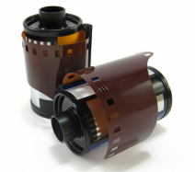


FILMING AND PHOTO SHOOT APPLICATION FORM
Please fill out with as much detail as possible to assist with
processing this application and email to filming.permits@televisioncentre.com

Date:
Name:
Tel No:
Company:
For and Behalf of:
Location(s) required:
Start Date:
Start Time:
End Date:
End Time:
Description of Shoot:
If your application is approved, we will require a risk assessment, method statement,
a valid copy of public liability and employer’s liability insurance certificate (limits as set in Filming Guidelines)

